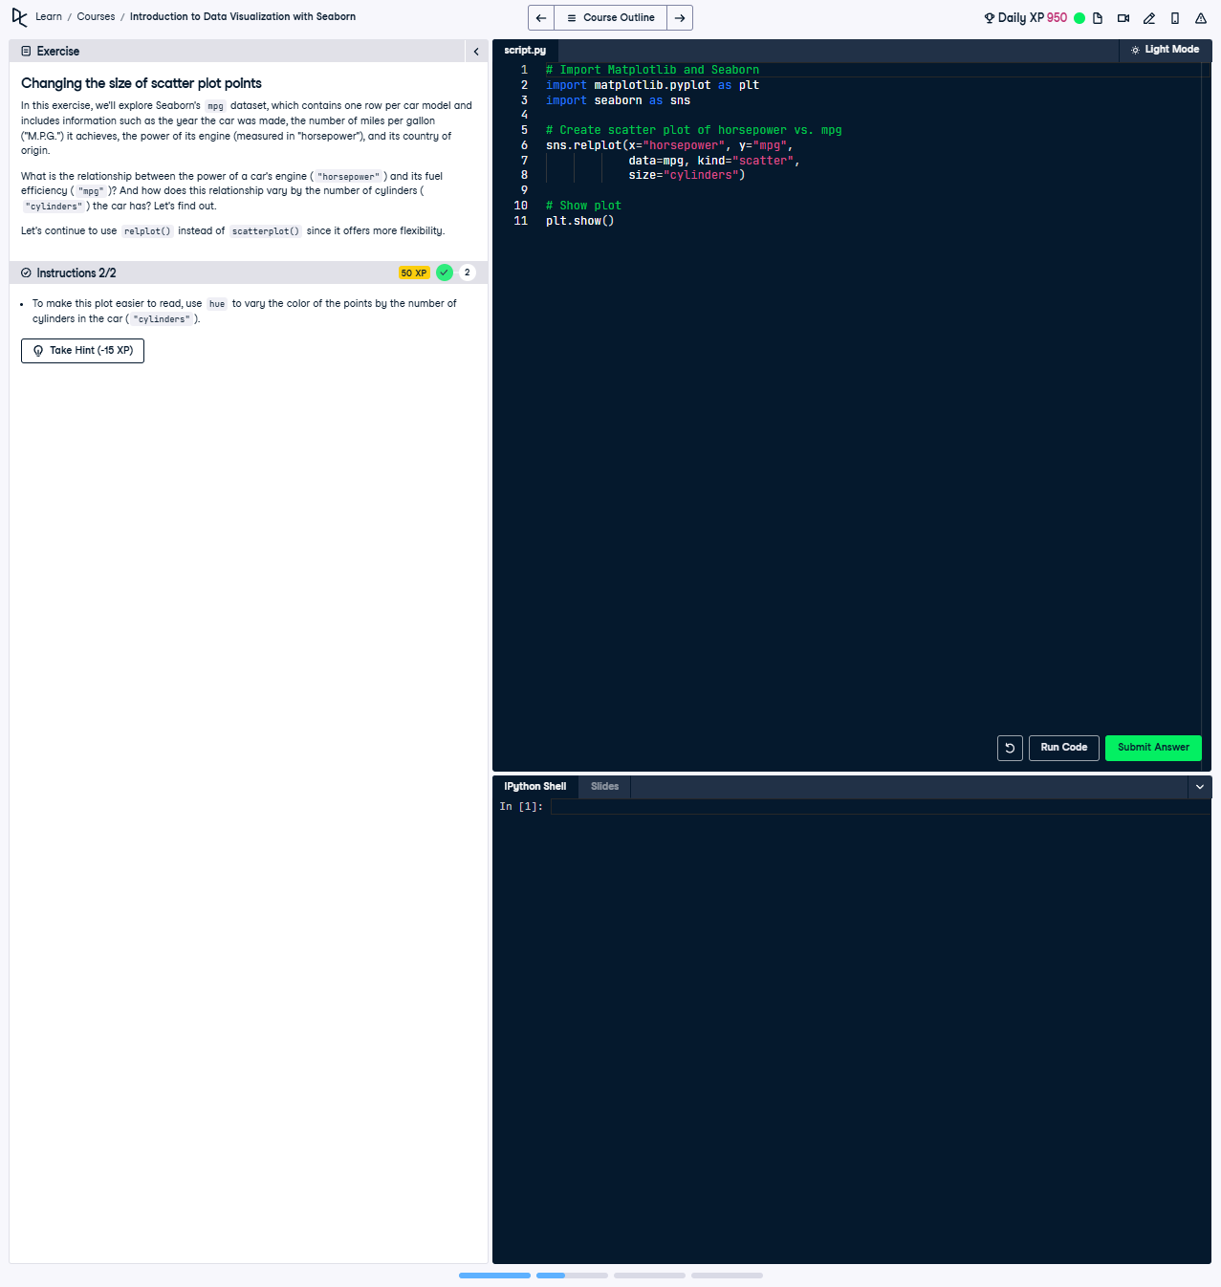

Changing the Size and Color of Scatter Plot Points

To make the scatter plot more useful, vary the color of the points by the number of cylinders in the car ('cylinders'). Use relplot() with 'horsepower' on the x-axis and 'mpg' on the y-axis, and adjust the point size and color accordingly.

### Full Answer ###

The following code creates a scatter plot using relplot(). It varies both the size and color of the points based on the number of cylinders in the car ('cylinders'). Below is the working code:

import seaborn as sns  
import matplotlib.pyplot as plt  
  
# Create scatter plot of horsepower vs. mpg with point size and color based on cylinders  
sns.relplot(x='horsepower', y='mpg',  
 hue='cylinders',  
 size='cylinders',  
 data=mpg,  
 kind='scatter',  
 sizes=(10, 200))  
  
# Show plot  
plt.show()

### Code Explanation ###

1. Import seaborn and matplotlib.pyplot for creating visualizations.  
2. Use sns.relplot() to create a scatter plot with:  
 - 'x' set to 'horsepower' for engine power.  
 - 'y' set to 'mpg' for fuel efficiency.  
 - 'hue' set to 'cylinders' to vary the color of the points.  
 - 'size' set to 'cylinders' to adjust the size of the points.  
 - 'data' set to mpg, the DataFrame containing the data.  
 - 'kind' set to 'scatter' to generate scatter plots.  
 - 'sizes' set to (10, 200) to control the range of point sizes.  
3. Use plt.show() to render and display the plot.